Saint Agnes Church First Sunday of Advent
Morning Prayer November 27, 2022 @ 8:30 am

Zoom Meeting ID: 326 920 7504
Call-in option: 1) Dial 646-568-7788 or 929-205-6099, 2) Enter 326 920 7504 # and 3) Press # for a participant's ID
Hymn #56 O come, O come, Emmanuel Words: Latin, ca. 9th cent.
Music: Veni, veni, Emmanuel

The Invitatory and Psalter

Officiant Show us your mercy, O Lord:
Celebrants And grant your salvation.
Officiant Come and save us, O Lord God of hosts.
Celebrants Come and save us, O Lord God of hosts.
Officiant Show the light of your countenance, and we shall be saved:
Celebrants O Lord God of hosts.
All Glory to the Father, and to the Son, and to the Holy Spirit:
Come and save us, O Lord God of hosts.

Officiant The mercy of the Lord is everlasting: Come let us adore him.

Venite Psalm 95:1-7
All Come, let us sing to the Lord; *
let us shout for joy to the Rock of our salvation.
Let us come before his presence with thanksgiving *
and raise a loud shout to him with psalms.
For the Lord is a great God, *
and a great King above all gods.
In his hand are the caverns of the earth, *
and the heights of the hills are his also.
The sea is his, for he made it, *
and his hands have molded the dry land.
Come, let us bow down, and bend the knee, *
and kneel before the Lord our Maker.
For he is our God, and we are the people of his pasture and the sheep of his hand. *
Oh, that today you would hearken to his voice!

Officiant The mercy of the Lord is everlasting: Come let us adore him.

The Lesson

Reader A Lesson from Matthew 24:36-44

Jesus said to the disciples, “But about that day and hour no one knows, neither the angels of heaven, nor the Son, but only the Father. For as the days of Noah were, so will be the coming of the Son of Man. For as in those days before the flood they were eating and drinking, marrying and giving in marriage, until the day Noah entered the ark, and they knew nothing until the flood came and swept them all away, so too will be the coming of the Son of Man. Then two will be in the field; one will be taken and one will be left. Two women will be grinding meal together; one will be taken and one will be left. Keep awake therefore, for you do not know on what day your Lord is coming. But understand this: if the owner of the house had known in what part of the night the thief was coming, he would have stayed awake and would not have let his house be broken into. Therefore you also must be ready, for the Son of Man is coming at an unexpected hour.”

Reader Hear what the Spirit is saying to the Church.
Celebrants Thanks be to God.

Romans 13:11-14
All You know what time it is,
how it is now the moment for you to wake from sleep.
For salvation is nearer to us now
than when we became believers;
the night is far gone,
the day is near.
Let us then lay aside the works of darkness
and put on the armor of light;
let us live honorably as in the day,
not in reveling and drunkenness,
not in debauchery and licentiousness,
not in quarreling and jealousy.
Instead, put on the Lord Jesus Christ,
and make no provision for the flesh,
to gratify its desires.
Glory to the Father, and to the Son, and to the Holy Spirit: *
as it was in the beginning, is now, and will be for ever. Amen.

Hymn #616 Hail to the Lord’s Anointed Words: James Montgomery
Music: German folk song

Reflection Paul Yoon

Advent prepares us for the coming of Christ. There are two kinds of “coming” that we anticipate. One is the birth of Jesus of Nazareth which dominates this liturgical season whereas the other is the second coming of Christ. Our popular culture focuses on the nativity scene. The second coming of Christ, however, is rather disregarded or ignored for various reasons. For this Advent season, I would like to invite all of us to pay attention to the latter aspect of Advent to take Jesus’ teaching on the coming of Christ into our hearts. This coming of Christ is also the disciples’ consistent interest and curiosity throughout the gospels.

Jesus always gives them a simple, straightforward answer to this question of when and where: “Don’t know when and where the eschatological coming will actually take place.” But he doesn’t stop there. He urges his friends to “be awake here and now.” St. Paul follows up on Jesus’ emphasis on the here-and-now nature of Christ’s coming and says, “You know what time it is, how it is now the moment for you to wake from sleep.”

The Advent message is way too simple then. Wake up from sleep right here and right now. Jesus has a sense of urgency that we can hear in the gospel lesson this morning. His parable of the owner of the house staying alert and ardent about staying up all night to guard his house against breaking in is the attitude that he would like his friends and us to have. Be alert and ardent always. This may sound a bit unrealistic and even stressful. Can we really continue to be awake? How do we actually do that?

Before adding more stress to our lives, especially during this holiday season, let’s unpack and undo our assumption about being awake. Too often, we assume and presuppose that we know what it means to be awake. But we usually don’t. Here, being awake is to give appropriate attention to the presence of God in ourselves. We keep in mind that God breathes into our breath. Keeping in mind, while being alert and keeping our ardency, is to be awake here and now.

This simple practice sounds like nothing so serious, yet once you actually do it, it may not be so hard. As we keep in mind God’s breath entering into our breath, we notice thoughts and feelings proliferate. It’s not that our thoughts and feelings are jumping around because we start meditating. Because we pause to breathe and contemplate, we can see what’s going on every second in our daily lives. What has been unseen or unnoticed is now exposed as we meditate. It’s like what Lao Tzu would say, “Do you have the patience to wait? Till your mud settles and the water is clear? Can you remain unmoving till the right action arises by itself?”

Jesus provides us with a great metaphor to have a more biblical theme to our practice of the Breath of God through our breath. The image that he coins is Noah’s Ark. I would like to invite all of us to briefly delve into how Noah ended up building the Ark. Below are the verses from the Book of Genesis with my comments in italics:

5 The Lord saw that the wickedness of humans was great in the earth and that every inclination of the thoughts of their hearts was only evil continually. 6 And the Lord was sorry that he had made humans on the earth, and it grieved him to his heart. 7 So the Lord said, “I will blot out from the earth the humans I have created—people together with animals and creeping things and birds of the air—for I am sorry that I have made them.” 8 But Noah found favor in the sight of the Lord. (6:5-8)

In God’s eyes, Noah is right with God. This cleansing act of God, however, contradicts the image of God who is loving, compassionate, and forgiving. I would not suggest that we take this story literalistically, but rather God’s anger acknowledges that evil does exist and still does in our days. Despite all the reasons to be dishonest, if not becoming evil ourselves, Noah keeps his integrity. When others go low, he goes high.

16 Make a roof for the ark, and finish it to a cubit above, and put the door of the ark on its side; make it with lower, second, and third decks. (6:16)

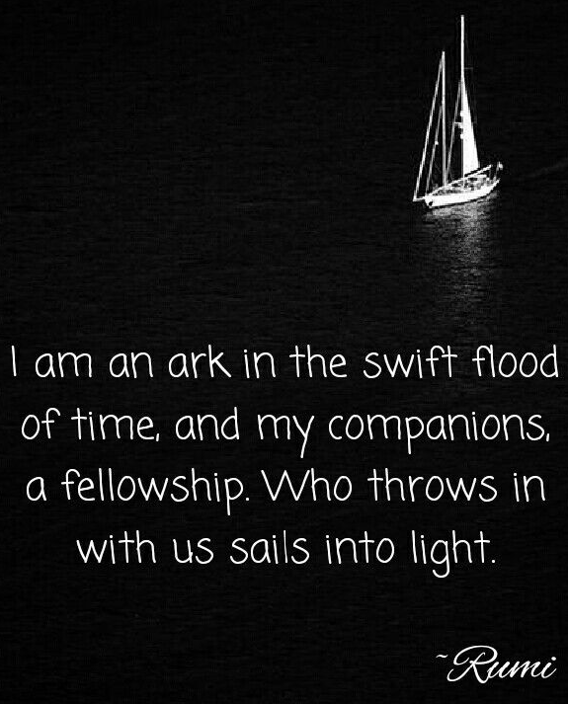
The Ark is designed to have no windows on the sides but only the roof on the top. Mechanically, no windows on the sides would prevent any water leak. Also, later when it finally stops raining after forty days and forty nights, Noah sends the raven and dove to see if the waters had subsided from the face of the ground. (8:6-8) Psychologically, Noah and his family are protected from seeing all the creatures, especially people drowning to death. This may prevent them from potential PTSD. Spiritually, Noah is focused on the roof, single-minded to set his eyes on the sky.

My friends, for this Advent season, I would like us to build this ark of the heart within. Remember what to keep in that ark. Keep in mind what’s most essential, which is the Breath of God. You will build a roof or a window that lets you focus on the presence of God only. Be alert to what you see in that window. Thoughts and feelings might come across. You can simply turn on your wipers to clear your sight. As the presence of God charges, restores, and energizes our hearts, we become ardent about maintaining the ark of the heart. Instead of forty days and forty nights of rain, we’re entering into four weeks of Advent. We yearn and long for the coming of Christ as we set our eyes on the window on the top of our inner ark through which the dove dawns upon us.

The Apostles' Creed

All I believe in God, the Father almighty, creator of heaven and earth;

I believe in Jesus Christ, his only Son, our Lord.
He was conceived by the power of the Holy Spirit
and born of the Virgin Mary.
He suffered under Pontius Pilate,
was crucified, died, and was buried.
He descended to the dead.
On the third day he rose again.
He ascended into heaven,
and is seated at the right hand of the Father.
He will come again to judge the living and the dead.

I believe in the Holy Spirit,
the holy catholic Church,
the communion of saints,
the forgiveness of sins,
the resurrection of the body,
and the life everlasting. Amen.

A Bidding Prayer for Advent

Officiant Dear People of God: In the season of Advent, it is our responsibility and joy to prepare ourselves to hear once more the message of the Angels, to go to Bethlehem and see the Son of God lying in a manger. Let us hear and heed in Holy Scripture the story of God’s ]loving purpose from the time of our rebellion against him until the glorious redemption brought to us by his holy Child Jesus, and let us look forward to the yearly remembrance of his birth with hymns and songs of praise.

But first, let us pray for the needs of his whole world, for peace and justice on earth, for the unity and mission of the Church for which he died, and especially for his Church in our country and in this city. And because he particularly loves them, let us remember in his name the poor and helpless, the cold, the hungry and the oppressed, the sick and those who mourn, the lonely and unloved, the aged and little children, as well as all those who do not know and love the Lord Jesus Christ.

Finally, let us remember before God his pure and lowly Mother, and that whole multitude which no one can number, whose hope was in the Word made flesh, and with whom, in Jesus, we are one for evermore. And now, to sum up all these petitions, let us pray in the words which Christ himself has taught us, singing:

Our Father, who art in heaven,
hallowed be thy Name,
thy kingdom come, thy will be done,
on earth as it is in heaven.
Give us this day our daily bread.
And forgive us our trespasses,
as we forgive those who trespass against us.
And lead us not into temptation,
but deliver us from evil.
For thine is the kingdom,
and the power, and the glory,
for ever and ever. Amen

Celebrant The Almighty God bless us with his grace;
Christ give us the joys of everlasting life;
and to the fellowship of the citizens above may the King of Angels bring us all. Amen.
The Supplication Pray responsively.

V. For the hungry and the overfed
R. May we have enough.
V. For the mourners and the mockers
R. May we laugh together.
V. For the victims and the oppressors
R. May we share power wisely.
V. For the peacemakers and the warmongers
R. May clear truth and stern love lead us to harmony.
V. For the silenced and the propagandists
R. May we speak our own words in truth.
V. For the unemployed and the overworked
R. May our impression on the earth be kindly and creative.
V. For the troubled and the sleek
R. May we live together as wounded healers.
V. For the homeless and the cosseted
R. May our homes be simple, warm and welcoming.
V. For the vibrant and the dying
R. May we all die to live.

The Collect for First Sunday of Advent
All Almighty God, give us grace to cast away the works of darkness, and put on the armor of light, now in the time of this mortal life in which your Son Jesus Christ came to visit us in great humility; that in the last day, when he shall come again in his glorious majesty to judge both the living and the dead, we may rise to the life immortal; through him who lives and reigns with you and the Holy Spirit, one God, now and for ever. Amen.

For the Future of the Human Race
Celebrant O God our heavenly Father, you have blessed us and given us dominion over all the earth: Increase our reverence before the mystery of life; and give us new insight into your purposes for the human race, and new wisdom and determination in making provision for its future in accordance with your will; through Jesus Christ our Lord. Amen.

For Families
Celebrant Almighty God, our heavenly Father, who settest the solitary in families: We commend to thy continual care the homes in which thy people dwell. Put far from them, we beseech thee, every root of bitterness, the desire of vainglory, and the pride of life. Fill them with faith, virtue, knowledge, temperance, patience, godliness. Knit together in constant affection those who, in holy wedlock, have been made one flesh. Turn the hearts of the parents to the children, and the hearts of the children to the parents; and so enkindle fervent charity among us all, that we may evermore be kindly affectioned one to another; through Jesus Christ our Lord. Amen.

For the Sick
Celebrant Heavenly Father, giver of life and health: Comfort and relieve thy sick servants, and give thy power of healing to those who minister to their needs, that those for whom our prayers are offered may be strengthened in their weakness and have confidence in thy loving care; through Jesus Christ our Lord. Amen.

For Protection
Celebrant Assist us mercifully, O Lord, in these our supplications and prayers, and dispose the way of thy servants towards the attainment of everlasting salvation; that, among all the changes and chances of this mortal life, they may ever be defended by thy gracious and ready help; through Jesus Christ our Lord. Amen.

For the Absent
Celebrant O God, whose fatherly care reacheth to the uttermost parts of the earth: We humbly beseech thee graciously to behold and bless those whom we love, now absent from us. Defend them from all dangers of soul and body; and grant that both they and we, drawing nearer to thee, may be bound together by thy love in the communion of thy Holy Spirit, and in the fellowship of thy saints; through Jesus Christ our Lord. Amen.

In the Morning
Celebrant This is another day, O Lord. We know not what it will bring forth, but make us ready, Lord, for whatever it may be. If we are to stand up, help us to stand bravely. If we are to sit still, help us to sit quietly. If we are to lie low, help us to do it patiently. And if we are to do nothing, let us do it gallantly. Make these words more than words, and give the Spirit of Jesus. Amen.

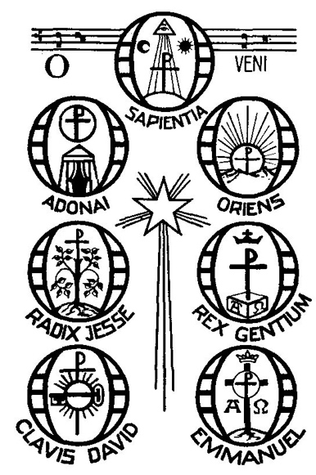
The General Thanksgiving

All Christ is the living water
cleansing, refreshing, making all things new.
Christ is the living bread;
food for the hungry,
strength for the pilgrim and the laborer.

So now we offer our thanks
for the beauty of these islands;
for the wild places and the bush,
for the mountains, the coast and the sea.

We offer thanks and praise to God for this good land;
for its trees and pastures,
for its plentiful crops
and the skills we have learned to grow them.

Our thanks for marae and the cities we have built;
for science and discoveries,
for our life together,
for our world.

Officiant Let us bless the Lord. Alleluia, alleluia!
Celebrants Thanks be to God. Alleluia, alleluia!

Officiant May Almighty God, by whose providence our Savior Christ came among us in great humility,
sanctify us with the light of his blessing and set us free from all sin. Amen.
May he whose second Coming in power and great glory we await,
make us steadfast in faith, joyful in hope, and constant in love. Amen.
May all of, who rejoice in the first Advent of our Redeemer,
at his second Advent be rewarded with unending life. Amen.

Saint Agnes Church
65 Union Ave, Little Falls, NJ 07424
Serving people of Little Falls and surrounding communities since 1896,
Saint Agnes Church is a part of the Episcopal/Anglican branch
of the Jesus Movement in the Diocese of Newark, striving to be a contemplative community.

